First, I need to clarify that our mission is a supervised learning situation. The assignment says I need to use Semi-AAE to finish this. However, Semi means Semi-supervised learning which is not suitable for this question. It is hard for the generative models to produce not fixed length sequence, but I can also do that. I can also turn some supervised data into unsupervised data. The reason I do not use generative models is that I think what we need to improve now is not model, it should be your datasets. Correcting datasets will improve much accuracy than changing a more complex model. So I use GRU (Gated Recurrent Unit) to finish this work.

I think there are some serious problems in your datasets. There are many positive reviews in neg.txt and negative reviews in pos.txt. For example, you can search the key words “不错” in neg.txt and you will find many positive reviews. Or “价格便宜，够实惠，声音也不错” is also an obvious positive review example in neg.txt. Although there are my serious problems in the datasets, my accuracy is also over 90 percent under such situation.

I want to introduce the five parts in my submitted file.

1. dataset: the original file contains the original pos and neg txt files you gave me; the preprocessed data contains four files, the test file is the data for test, the train file is the data for train, the valid file is the data for valid and the embedding is the word vector; the preprocess.py is the code of preprocess.
2. parameters: this is the parameters produced when we train our model
3. incorrect_sample.txt: this is the wrong classified data and I collected them into this txt file. You can see that there are many reviews which are not positive or negative, like “暂时没有发现缺点”，”正在使用中”. This is also the problem of dataset.
4. testing.py: this is what you can have a try. Please install word2vec and Pytorch in your computer. I run the testing code in Linux as follows:

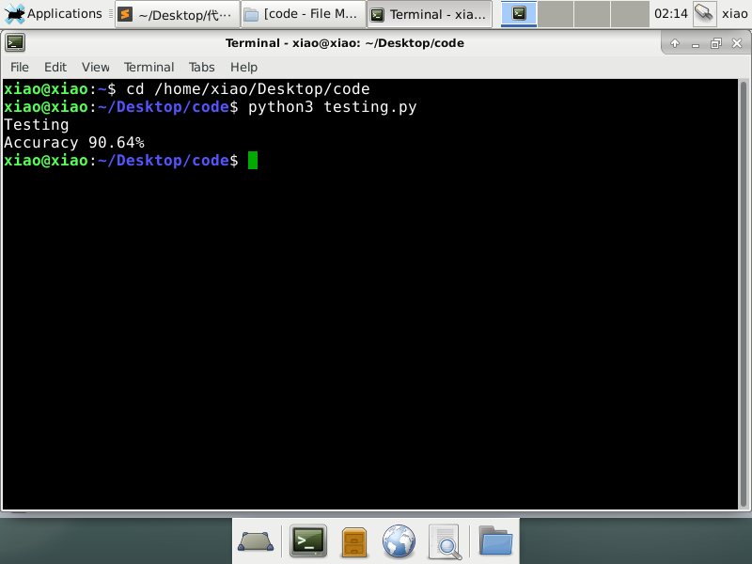

1. training_and_validation.py: this is the code of training and validation.

In the end, I get the accuracy of 90.64%. I believe if you get better datasets, the accuracy will be largely improved.